# Task 2 Design Brief

Using your research as basis, create specifications (a design brief of **up to two pages**) for the

mechanics and visual assets required to bring your game to life. Include at least:

1. **Target Device:** The target device is the computer because it uses the keyboard and mouse for movement and shooting.
2. **Gameplay Flowcharts :**

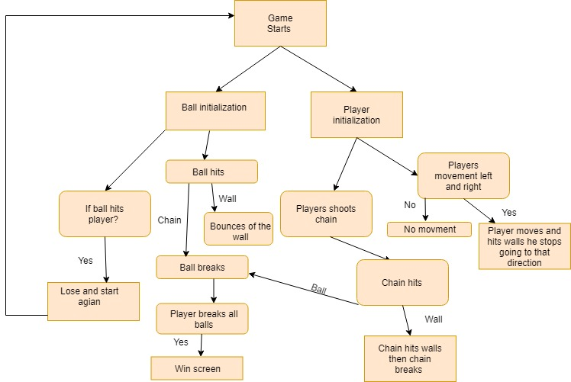

1. **Game Mechanics :**

Shooting the bouncing ball that will then split into smaller balls and keep splitting until they become the smallest ball which when shot disappears.

1. **Game Objectives, if any**

Destroy all the balls and their splits while trying to dodge and never to get hit and kill your character.



1. 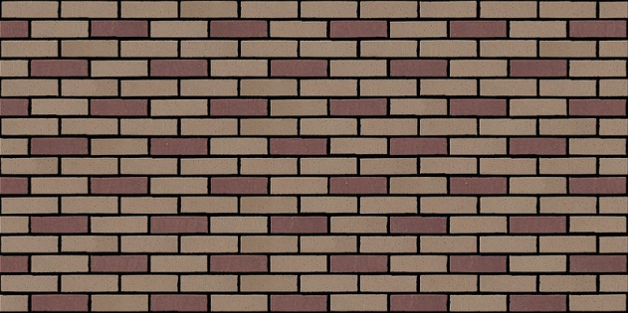**Visual Assets (2D / 3D)**



The player character with devil sprite

Background wall image

The ball in this case is an ice ball sprite

1. **UI Elements**

2 text buttons one to play game and one to exit.

 

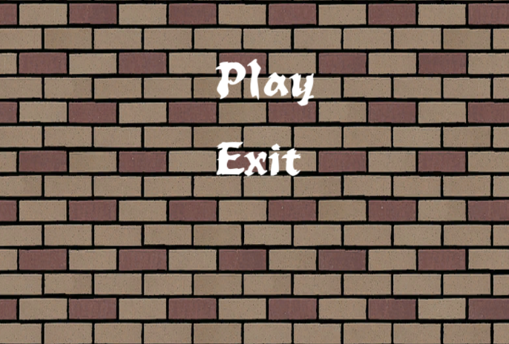

1. **Game Scenes**

Main Menu

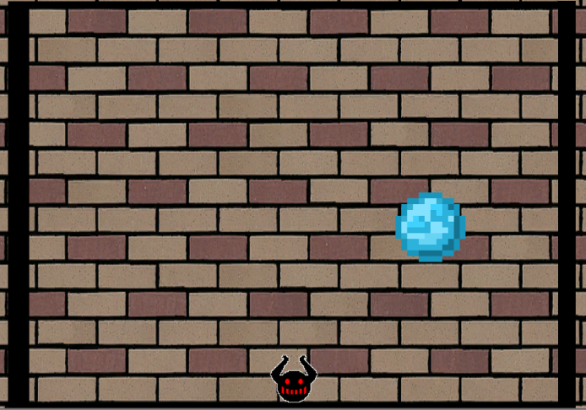

MainScene

AKA The game

<http://www.rebubbled.com/>

<https://www.youtube.com/watch?v=4jGVesn7O4g&t=2476s>

<https://www.youtube.com/watch?v=zc8ac_qUXQY>